****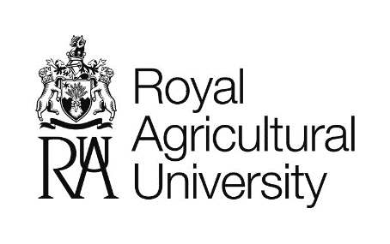

**Professor Barry Dent Scholarship & International Exchange**

**Application Form 2025 -2026**

|  |  |
| --- | --- |
| **Full Name** |  |
| **Email address** |  |
| **Address** |  |
| **Postcode** |  |
| **Telephone Number** |  |
| **Date of Birth** |  |
| **Nationality** |  |
| **Course** |  |
| **Student number** |  |
| **Course start date**  **MM/YYYY** |  |
| **Course End Date**  **MM/YYYY** |  |
| **Personal Achievements – Sports played, club or team memberships, awards etc** |  |

|  |  |
| --- | --- |
| **Questions about the exchange**  Please answer the questions below | |
| **What do you want to achieve by attending this exchange?**  *Maximum 200 words* |  |
| **Have you any previous experience of travelling abroad?** |  |
| **Why would you be a good ambassador for the RAU, for agricultural education and UK agriculture more widely?** |  |
| **Do you require any disability support?**  This information will not be used to assess your application, we want to make sure that all of our students get the most the exchange and by telling us about your disability, we can identify any support that you might need. |  |

#### Terms and Conditions can be found on the website at <https://www.rau.ac.uk/student-life/finance-scholarships-and-bursaries/prof-barry-dent-scholarship>