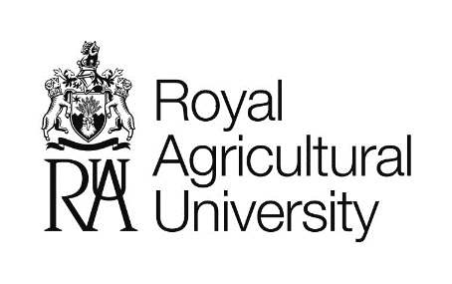

**Kaleb Cooper Bursary Application Form 2025**

|  |  |
| --- | --- |
| **Full Name** |  |
| **Email address** |  |
| **Address** |  |
| **Postcode** |  |
| **Telephone Number** |  |
| **Date of Birth** |  |
| **Nationality** |  |
| **Course** |  |
| **Student number** |  |
| **Course start date**  **MM/YYYY** |  |
| **Course End Date**  **MM/YYYY** |  |
| **Personal Achievements – Sports played, club or team memberships, awards etc** |  |
| **Financial Need**  *If you have financial circumstances that you would like us to take into consideration, please use this space to tell us about it.* |  |

The following page contains questions about your passion for agriculture and what you hope to achieve in the sector.

|  |  |
| --- | --- |
| **Questions about agriculture**  Please answer the questions below **OR** film a video answering these, upload it to YouTube and send us the link.  Please note that if you chose to submit a video, this may be used as part of a montage for publicity for the bursary and/or at the announcement of the winning student. | |
| **What was your background before coming to study at the RAU?** *Including do you have a background in farming?* |  |
| **In a minimum of 100 words, please explain why you are passionate about agriculture?** |  |
| **What would be your ideal job in agriculture after leaving the RAU?** |  |
| **Why would you be a good ambassador for the RAU, for agricultural education and UK agriculture more widely?** |  |

|  |  |
| --- | --- |
| **\*\*OR**  **Link to YouTube Video** |  |