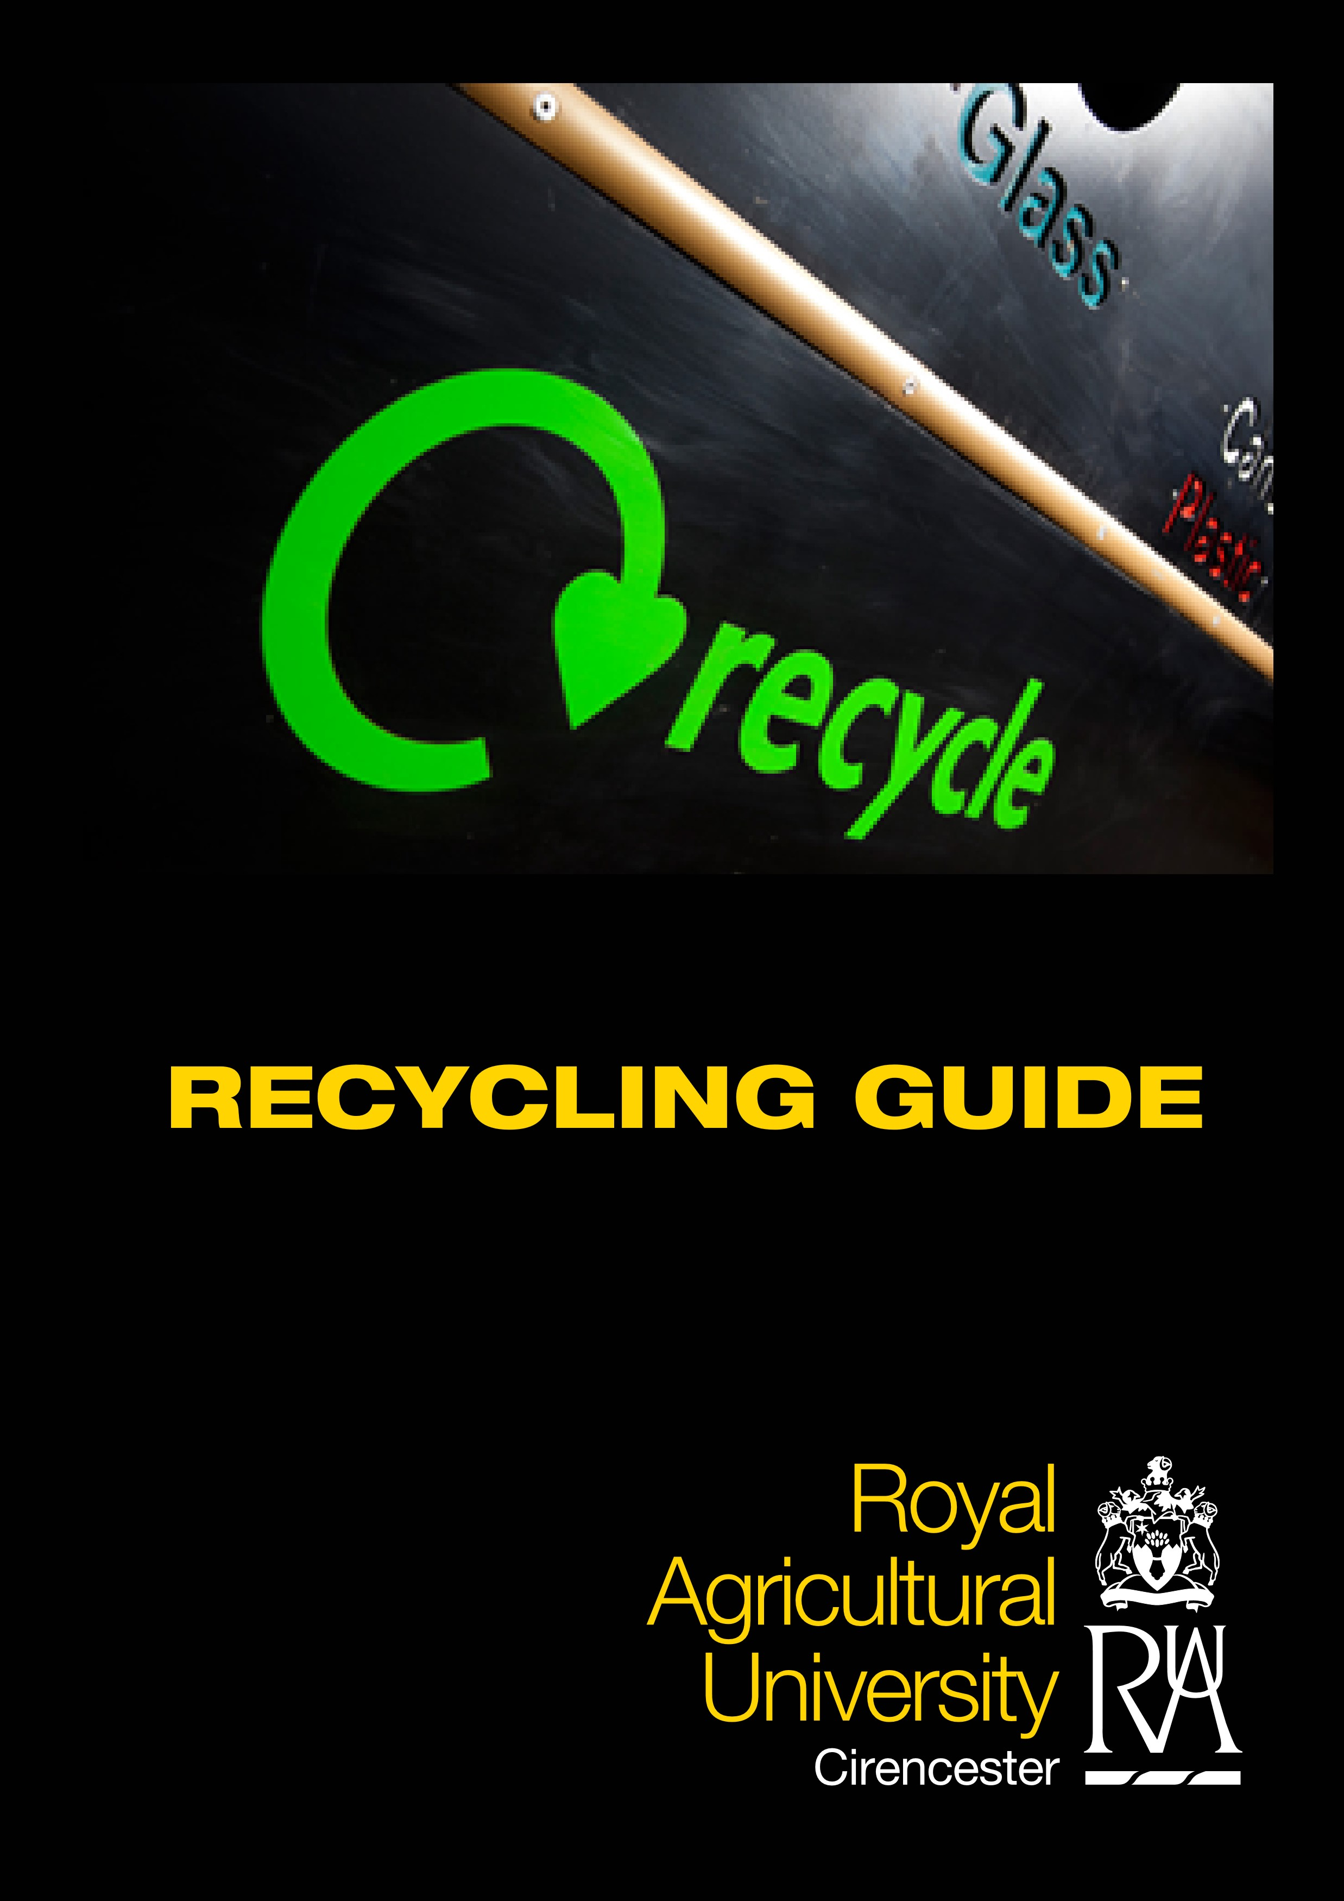

Introduction
The University is committed to reducing the impact it has on the environment through promoting sustainable waste management principles. In order for us to be successful in doing this we need everyone’s help to make sure that we manage our waste appropriately.
One of the ways in which we can do this is to ensure that we are recycling as much waste as we can. This guide provides information about what to do with your waste on campus in order to ensure that as much of it is recycled as possible. We are already able to recycle most types of waste, and we are working on being able to recycle even more.
This guide is split into three sections:
- a guide to the main types of waste, and what you should do with each of them whilst on campus
- a map showing the main recycling sites on campus
- a useful information section on the back page giving details about who to contact if you have any queries about waste whilst on the on campus, plus website details for the nearest local authorities for students and staff living off-campus who have queries about what to do with their waste at home.
This guide is mainly designed to provide information for students living on the University campus, and also guidance for staff, students living off-campus, and visitors, about what to do with the waste produced whilst they are on the campus. Waste that is produced off-campus (i.e. at home) should be dealt with via your local authority’s waste and recycling collections and centres (see contact information on the back page).
Students, staff and visitors are advised to make their own arrangements for disposing of their own personal furniture, equipment and vehicles (i.e. those not owned by the University). If any such item is left for the University to dispose of, then the costs arising from doing so will be charged to the relevant individual.
The waste hierarchy (shown below) sets out the order of options to consider when managing waste sustainably.

Prevention
(the best option as it reduces the amount of waste produced)

Re-use
(for example, reusing carrier bags as bin liners)

Recycling
(using the materials from waste in order to produce something new; for example, recycling metal and glass)

Recovery
(usually used in relation to producing energy from waste – for example, burning waste to produce energy)

Disposal
(considered to be the worst option, as it normally involves waste ending up in landfill sites)
Recycling is an important stage of the waste hierarchy; however, it is also worthwhile remembering that it is generally considered that prevention (i.e. reducing the amount of waste that is created in the first place) and re-use (where appropriate) are better options. The University’s website provides information about what we are already doing to minimise the amount of waste we are producing, and we are working on continually improving this, part of which is the binless office project.
Where it is not feasible to prevent waste being created, or to re-use items, then recycling makes an important contribution to sustainable waste management, so we aim to recycle as much as possible. If you have any suggestions as to how we can make it easier to recycle at the University please contact us (see back page for contact details).

Recycling Information for Students on Campus, Staff & Visitors

Office Paper
Recycling bins for office paper can be found in:
Computer rooms Staff office areas
General Paper
Recycling stations (1) & (2) – see map

Confidential Paper
Confidential paper waste should be deposited in one of the Shred-it secure paper bins. These are located in:
- Porters’ Lodge
- One in each of the three Schools
Once full, the bins are taken away, the paper is securely destroyed, and it is then recycled.

Cardboard
For large quantities of cardboard / boxes, please contact Porters’ Lodge who can arrange for it to be collected by a support technician. Some departments also have scheduled collections – please check with your line manager. We do not yet have a system for dealing with smaller quantities of cardboard; however, we are working on this.
PLEASE NOTE: Large quantities of cardboard should NOT be left lying around as it is a fire, and health and safety risk.
Once collected, cardboard is compacted on site and is then collected for recycling.
PLEASE NOTE: For safety reasons, only those people who have been trained to use the cardboard compactor
are permitted to use it. DO NOT use it unless you have received appropriate training.

Plastic
Recycling bins for plastic can be found in:
- Recycling stations (1) & (2) – see map
- Most of the staff office recycling areas
- Main recycling centre (5) (Stroud Road Car Park) – please use this site for larger quantities.
We are able to recycle plastic with the following labels:
PVC
As a guide, this usually includes the types of bottles that have held fizzy drinks, water, cooking oil, milk, fruit juice or detergents. They can be coloured or clear, and can include tops; however, please make sure they are clean. There is no need to remove labels.
There are some types of plastic we are not yet able to recycle, so please do not put the following items into the plastic recycling bins: yoghurt pots, margarine tubs, plastic film, carrier bags, meat trays, or containers for medicines, motor oil, garden or toxic chemicals.

Glass
Small quantities of glass jars and bottles (any colour) can be deposited in:
- Recycling stations (1) & (2) – see map
Larger quantities of glass jars and bottles should be divided up into clear, brown, and green glass and put into the appropriate recycling bins located in:
- Main recycling centre (5) (Stroud Road Car Park)
- Recycling centre (4) (Woodland Car Park)
- Recycling centre (3) (Cedar Lodge)
Please ensure bottles are clean and lids are removed.

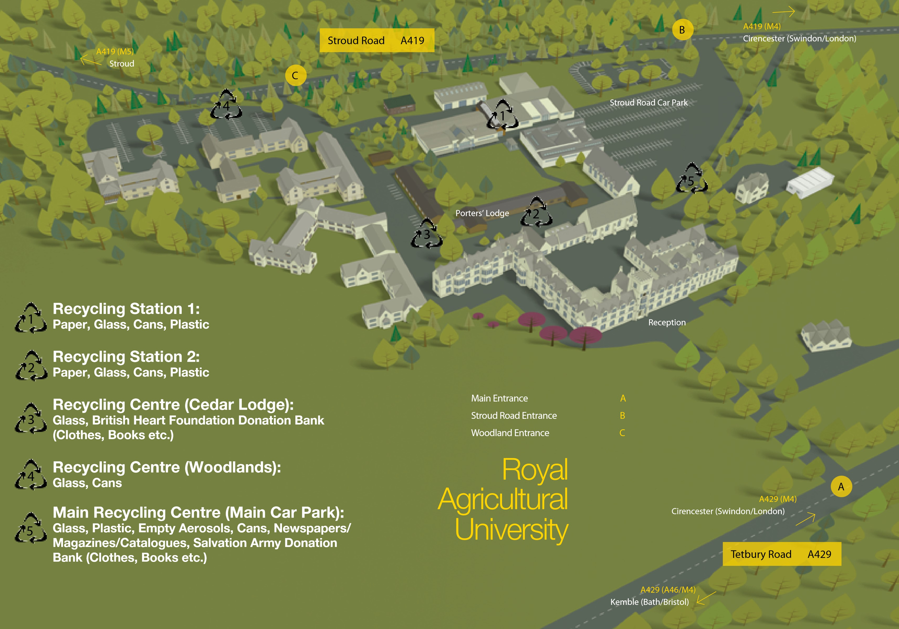

Steel & Aluminium Cans
Recycling bins for these can be found in:
- Recycling stations (1) & (2) – see map
- Main recycling centre (5) (Stroud Road Car Park)
- Recycling centre (4) (Woodland Car Park)
- Recycling centre (3) (Cedar Lodge)
PLEASE NOTE: Cans must be clean and free of food before putting into the recycling bins. Lids should be put inside cans to prevent accidents whilst transporting.

Empty Aerosols
Recycling bin in:
• Main recycling centre (5) (Stroud Road Car Park)
PLEASE NOTE: For safety reasons, ensure that your aerosol is completely empty before placing in the recycling bin and do not pierce, crush or flatten the aerosol before putting in the recycling bin. Please ensure that easily removable parts, such as lids, are removed.

Batteries
Recycling points for small alkaline batteries (up to size D) in:
- Porters’ Lodge
- Front Reception
- University Shop
- Library
- Starbucks
Alkaline batteries are the non-rechargeable batteries that are normally used in remote controls, torches, clocks etc.
We do not presently have any recycling facilities for other types of batteries and there will be transferable costs for their disposal. Please contact the Estates and Facilities department if you have any queries.

Metal & Wood
Please contact the Estates and Facilities department if you have any redundant metal or wood.

Books
Current textbooks, in good condition, can be sold on to students via the University shop.
Other good quality books can be donated to charity in two places on campus:
- Salvation Army – book bank in the main recycling centre (5) – Stroud Road Car Park
- British Heart Foundation – recycling centre (3) (Cedar Lodge)

Clothing & Shoes for Charitable Donation
Good quality clothing and shoes can be donated to charity in two places on campus:
- Salvation Army – main recycling centre (5) – Stroud Road Car Park
- British Heart Foundation – recycling centre (3) (Cedar Lodge)
Only good quality, clean, clothing and shoes (i.e. not rags) should be deposited in the charity donation banks. More guidance on donations is displayed on the banks.

Other Items for Charitable Donation
A range of good quality items, including CD’s, DVD’s, videos, PC and video games, handbags and accessories can be donated to charity through depositing in our charity donation banks which are situated in the following locations:
- Salvation Army – main recycling centre (5) – Stroud Road Car Park
- British Heart Foundation – recycling centre (3) (Cedar Lodge)
Further information about what can be donated is displayed on each of the charity banks.

Kitchen Oil
Waste oil used in the University kitchens is collected and recycled by our supplier. We do not currently have a mechanism for collecting waste kitchen oil from our self-catering halls of residence as we only have a very small number of these; however, if you have any queries about this, please contact us.

Electrical Equipment
PLEASE NOTE: Electrical equipment is classified as hazardous waste so should not be put in general waste bins.
For guidance and advice on disposal, please contact the Estates and Facilities department.

Light Bulbs / Fluorescent Tubes
PLEASE NOTE: All types of light bulb (traditional filament, fluorescent tubes and energy saving bulbs) should be reported to Porters’ Lodge for removal and replacement. DO NOT attempt to remove them yourself.
Fluorescent tubes and energy saving bulbs are classified as hazardous because they contain small amounts of mercury. They, therefore, should not be put in with general waste. Members of staff who are authorised to remove and replace light bulbs will ensure that they are dealt with appropriately.

Landfill Waste (& Potentially Hazardous Waste)
The University is currently able to recycle most types of waste. There are, however, some things that we cannot yet recycle and we are working on ways of improving this. If you have an item of waste which we are not yet able to recycle (and / or it is not covered specifically in this guide) it should be put in the general waste bins around campus unless you think it may be hazardous waste (in which case, see note below). If you are unclear as to whether an item can be recycled or not, please contact Phil Wood (see page 9 for contact details).
PLEASE NOTE: If you think that the waste you wish to dispose of may be hazardous waste, contact the Estates and Facilities department to arrange removal. DO NOT put it into general waste.

Useful Information / Contact Details

University Contacts
To arrange collection of specific waste items (as shown in the guide):
Estates & Facilities Department
Extension: 2201
For further information / queries relating to waste and recycling at the University:
Phil Wood, Facilities Manager, Royal Agricultural University
Email: phil.wood@rau.ac.uk Extension: 2201
Useful Websites

Cotswold District Council
Waste & recycling information for students / staff living off-campus in the Cotswold District Council area:
http://www.cotswold.gov.uk/nqcontent.cfm?a_id=418

Wiltshire Council
Waste & recycling information for students / staff living off-campus in the Wiltshire Council area: http://www.wiltshire.gov.uk/rubbishrecycling.htm

Recyclenow
Website providing general information about recycling, including what can be recycled and where, together with how different products are recycled:
http://www.recyclenow.com
Uni 22/4/13 10

