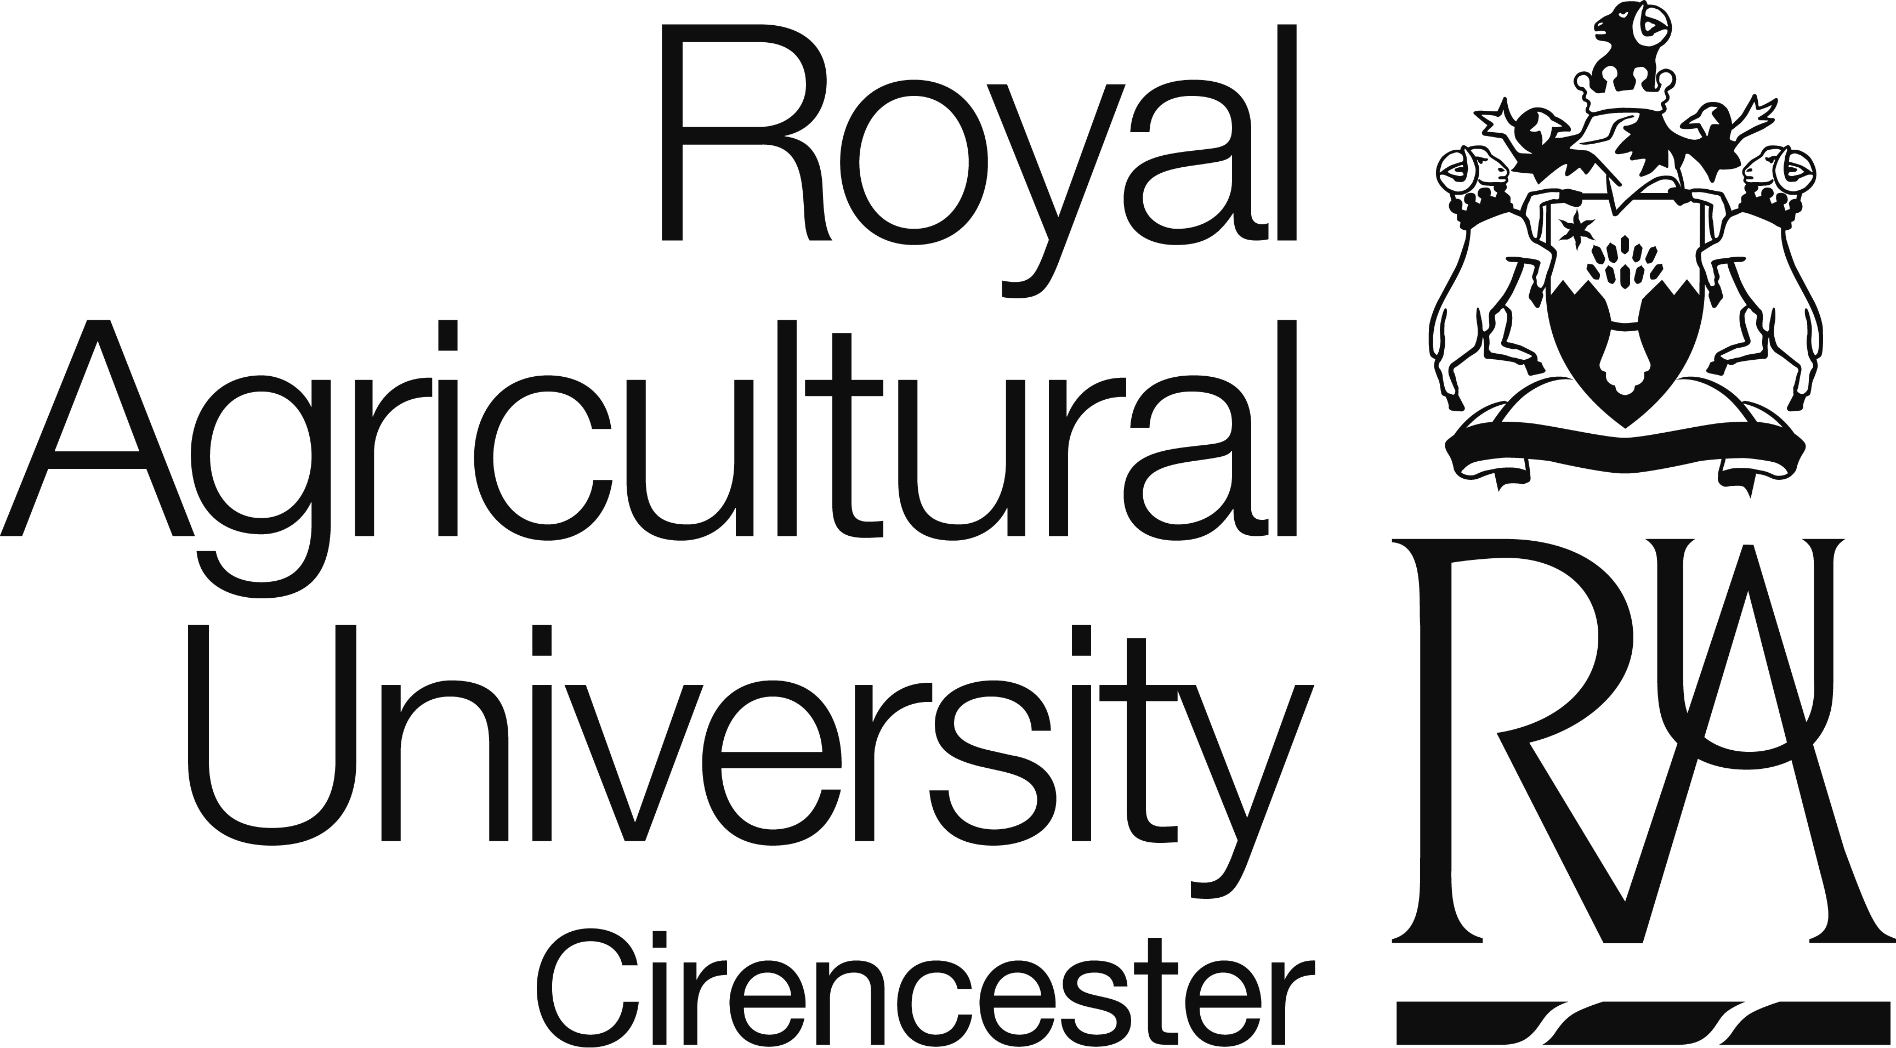

Programme Specification

MSc Business Management

MSB GUIDE – SEPTEMBER 2018

ROYAL AGRICULTURAL UNIVERSITY, CIRENCESTER

PROGRAMME SPECIFICATION

MSc Business Management

NB
The information contained in this document is intended only as a guide to the programme. It does not constitute a legally binding document or contract between the individual and the Royal Agricultural University.

The information contained herein is correct at the time of going to print, but the University reserves the right to make changes to the structure of the programme, assessment methods, etc. at any time without prior notification. Any changes made however will be made known as soon as possible.

Programme Manager – Jonathan Brunyee

© The Royal Agricultural University. September 2017

- Awarding Institution | Royal Agricultural University (RAU)
- Teaching Institution | RAU
- Final Award Title(s) | MSc Business Management
- Academic level on Framework for Higher Education Qualifications (FHEQ) | Level 7
- UCAS Code(s) | N/A
- Relevant QAA Subject Benchmark Statement(s) and other reference points | QAA Master’s degree characteristics (2010).  QAA Master’s level Subject Benchmark Statement for Business and Management (2007).
- Details of accreditation by a professional/statutory body | N/A
- Mode of study | Full time or part time.
- Language of study | English
- Date of production/revision | September 2017
- Educational Aims of the Programme
The Programme Management Group aim to:

- Develop an approach to critical management studies which enables students to differentiate theories about management and theories for management and prepares individuals to be academics, managers and business specialists

and, via a coherent teaching strategy allow students to:

- Develop a broad knowledge and a conceptual base of business theories in the field of agricultural business, wine business, food business, equine business or international trade.
- Develop enquiring and creative minds tempered with critical and logical thinking for lifelong learning.
- Learn and practice the key skills required for both autonomous practice and team working.

- Intended Learning Outcomes

Knowledge and Understanding
The student will know and understand:
- Financial, Operational, Economic, Strategic, Marketing, Management and Change theories and applications relating to corporate, small and medium enterprises, in an International context. (A1)
- A theoretical basis of research methodologies appropriate to business management (A2).
- Recent developments in the related industry through the elective modules (A3).

Teaching and learning strategies
Knowledge and understanding will be acquired via lectures, seminars, visits and guided specific independent and specific group work. Assessment will be via examinations and coursework including case studies, reports, presentations and the dissertation.

Cognitive skills
The student will be able to:
- Interpret data and abstract meaning (B1).
- Identify, source and evaluate information (B2).
- Identify and evaluate conceptual issues (B3).
- Demonstrate independence of thought (B4).
- Demonstrate the skills necessary to plan, conduct and report original research (B5).
- Critically analyse literature (B6).

Teaching and learning strategies
Intellectual skills are developed through the teaching and learning programme. The programme involves discussion of key issues. Evaluatory and analytical skills are assessed through the presentations, case studies and the dissertation. Through the dissertation, in particular, students will be able to demonstrate their thinking and research skills.

Practical skills
The student will be able to:
- Evaluate business performance (C1).
- Write for different audiences (C2).
- Locate and critically appraise data and information from a variety of sources (C3).
- Produce a bibliographically based piece of research (C4).
- Choose between theories appropriate to various business situations (C5).
- Construct and apply various survey techniques, e.g. questionnaires and interviews (C6).

Teaching and learning strategies
Practical based skills will be developed through the teaching and learning programme and via the coursework, presentations and dissertation. Skills are further developed through feedback on written coursework and through the construction of a research proposal and the dissertation.
Transferable Skills
The student will be able to:
- Produce work and perform effectively in groups (D1).
- Work effectively independently (D2).
- Communicate effectively through presentations (D3).
- Effectively use Communication and Information Technology (D4).
- Learn through self reliance (D5).

Teaching and learning strategies
Transferable skills are acquired and assessed through examinations, coursework, seminars, presentations, the research proposal and dissertation.

- Programme Structure and requirements

Student workload
All academic programmes at the RAU are constructed using a selection of modules, each of which requires engagement with a variety of learning activities. Successful completion of module assessments will result in the award of credits, and students are required to achieve a total of 120 credits for the taught postgraduate diploma element followed by a further 60 credits for completion of the dissertation leading to the award of MSc.

The credit system is used to ensure a balanced workload across each programme, with each credit point representing a notional learning time of 10 hours of student work. Thus a 15-credit module will require a notional input of 150 hours of work, and a complete academic year of 120 credits (i.e. postgraduate diploma) will require 1200 hours of work, or approximately 40 hours per week.

Within this total time, students can expect to participate in formal timetabled activities; such as lectures, seminars, tutorials, practicals and visits; for approximately one third of the total time – usually around 2 – 3 hours per week for a 15-credit module, studied over a 15 week semester. Thus the majority of module activities; such as reading around the subject, preparing for tutorials and seminars, preparing for, and completing, module assessments and revision for, and sitting, examinations; will take place outside of these scheduled activities, but are an essential part of a student’s learning journey.

Students attempting to short-cut their learning activities may find themselves experiencing difficulties as each module progresses, and as the level of assumed understanding increases. Thus it is vitally important that new students establish an effective routine for their studies as soon as possible. Maintaining a balanced workload from the start of the programme will help to avoid intense periods of activity, and ensure knowledge and understanding gradually develop throughout the year in readiness for any end-of-module examinations.

The programme is offered either full or part time. The eight taught modules run over two semesters (4 in each semester) from October to June. A dissertation or research project worth 60 credits is undertaken and submitted by the end of September.

The eight taught modules are divided into six core modules (90 credits) and 30 credits of elective modules.

Core modules:

Business Strategy | 15 credits
Economics and Policy | 15 credits
Financial Management | 15 credits
Marketing Planning and Strategy | 15 credits
Personal and Organisational Change | 15 credits
Research Methodology | 15 credits
Dissertation | 60 credits

Students must choose 30 credits from a given list of themed electives:
Business Studies

- Adaptive Management in a Complex World (15 credits)
- International Agri-Business, Finance and Investment (15 credits)
- Entrepreneurship (15 credits)
- International Business (15 credits)
- Corporate Finance (15 credits)

Rural Tourism & Event Management

- Rural Tourism and Event Management (15 credits)
- Equine Business Management

Farm Business Management

- Sustainable Agricultural Business Principles (15 credits)
- Farm Business Management (15 credits)

Food & Beverages

- Food Chain (15 credits)
- New Product Development in the Agri-Food Industry (15 credits)
- Small Scale Farming and Supply Chains (15 credits)
- Beverages and the Supply Chains (15 credits)

(Please note: electives choices are subject to timetable availability and minimum student numbers. Students are required to liaise with the relevant module leaders as to their elective choices and the final selection must be approved by the programme manager to ensure there is no duplication of learning outcomes and that students have the necessary pre-requisite knowledge. The list is correct at the time of print but further elective choices may become available and your programme manager will advise)

Credit accumulation and awards
Each full module is worth 15 credits and the dissertation is worth 60 credits. In order for a student to be awarded an MSc Business Management they must achieve 180 credits. A postgraduate diploma can be awarded for students who only complete the taught programme (120 credits) and a postgraduate certificate for those who only complete 60 credits from the taught programme.

Precise details of the learning outcomes together with assessments are included within the individual module reference sheets available from the RAU website http://rau.ac.uk/study/postgraduate-study/module-details.

The determination of the final award takes into account the taught programme (weighted 50%) and the dissertation (weighted 50%). Students have to achieve an average of 40% to pass the MSc.

- Student support services

Full details can be found in the Student Handbook and by visiting www.rau.ac.uk

- Criteria for admissions

Students will be expected to have:
- A minimum 2.2 honours degree from a UK university, or an equivalent academic qualification from a comparable international institution.
- Students whose first language is not English must achieve a minimum IELTS score of 6.5 or pass the RAU examination.
- Applicants without a first degree but with acceptable professional qualifications and/or acceptable management experience may also be considered.

The programme can be undertaken part-time by taking half the modules in the first year and the remaining modules in the second year. As the University does not currently offer distance learning it is unlikely that this will be attractive for overseas students.

- Teaching, learning and assessment
This programme is inclusive of disabled people (e.g. hearing impaired, vision impaired, speech impaired, dyslexic and mobility impaired) with particular regard to teaching, learning and assessment, in accordance with Part 10: Inclusive Practice of the University's Teaching Quality Handbook and the Equality Act 2010. Students are encouraged to disclose any impairment to the Disability Officer so that the appropriate support can be provided. Students have the right to request that the nature of their impairment be treated as confidential.

The teaching, learning and assessment strategies are outlined under the programme outcomes in section 12.

- Work-based learning

N/A.

- Quality Assurance Procedures

The RAU designates a Programme Manager (a member of RAU staff) with responsibility for all aspects of the day-to-day academic management and administration of the relationship with students.

The programme has been designed to fully comply with the Framework for Higher Education Qualifications (FHEQ) (level 7) and aligned with the Framework for Qualifications of the European Higher Education Area (FQ-EHEA).

The programme also complies with the Quality Assurance Agency’s (QAA’s) Master’s degree characteristics (2010), with the programme falling within category II (specialised / advanced study Master’s), and the QAA Master’s level Subject Benchmark Statement for Business and Management (2007).

- Marking Guides and Assessment Regulations

Full guidance can be found on the University website and in the Student Handbook.

- Ownership of programme specification

The Centre for Business and Enterprise

- Curriculum Map

See Annex 1.

- Career prospects

This programme provides the opportunity for future managers to gain understanding and experience of producers, processors, consumers and policy makers within Europe and an appreciation of its relationship with other major trading blocs. Furthermore, students will have the opportunity to broaden their knowledge in different industries such as agriculture, rural tourism, equine, wine business or international business. In fact, students will have access to a select group of sector consultants who have experience of leading firms across a broad range of sectors.

Students on the programme have come from a wide range of backgrounds, adding richness to the learning process and providing a wide range of cultural experiences and diversity within the MSc group.

On completing this programme, our graduates go on to work for a wide range of organisations both domestically and globally.

The University offers support to its careers and related services.

- Further information

Further information can be found by visiting the RAU website www.rau.ac.uk

- Module Reference Sheets

Module reference sheets are available from the RAU website: http://rau.ac.uk/study/postgraduate-study/module-details

